BALTIC SEMINAR
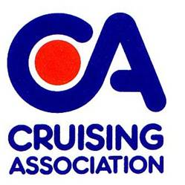
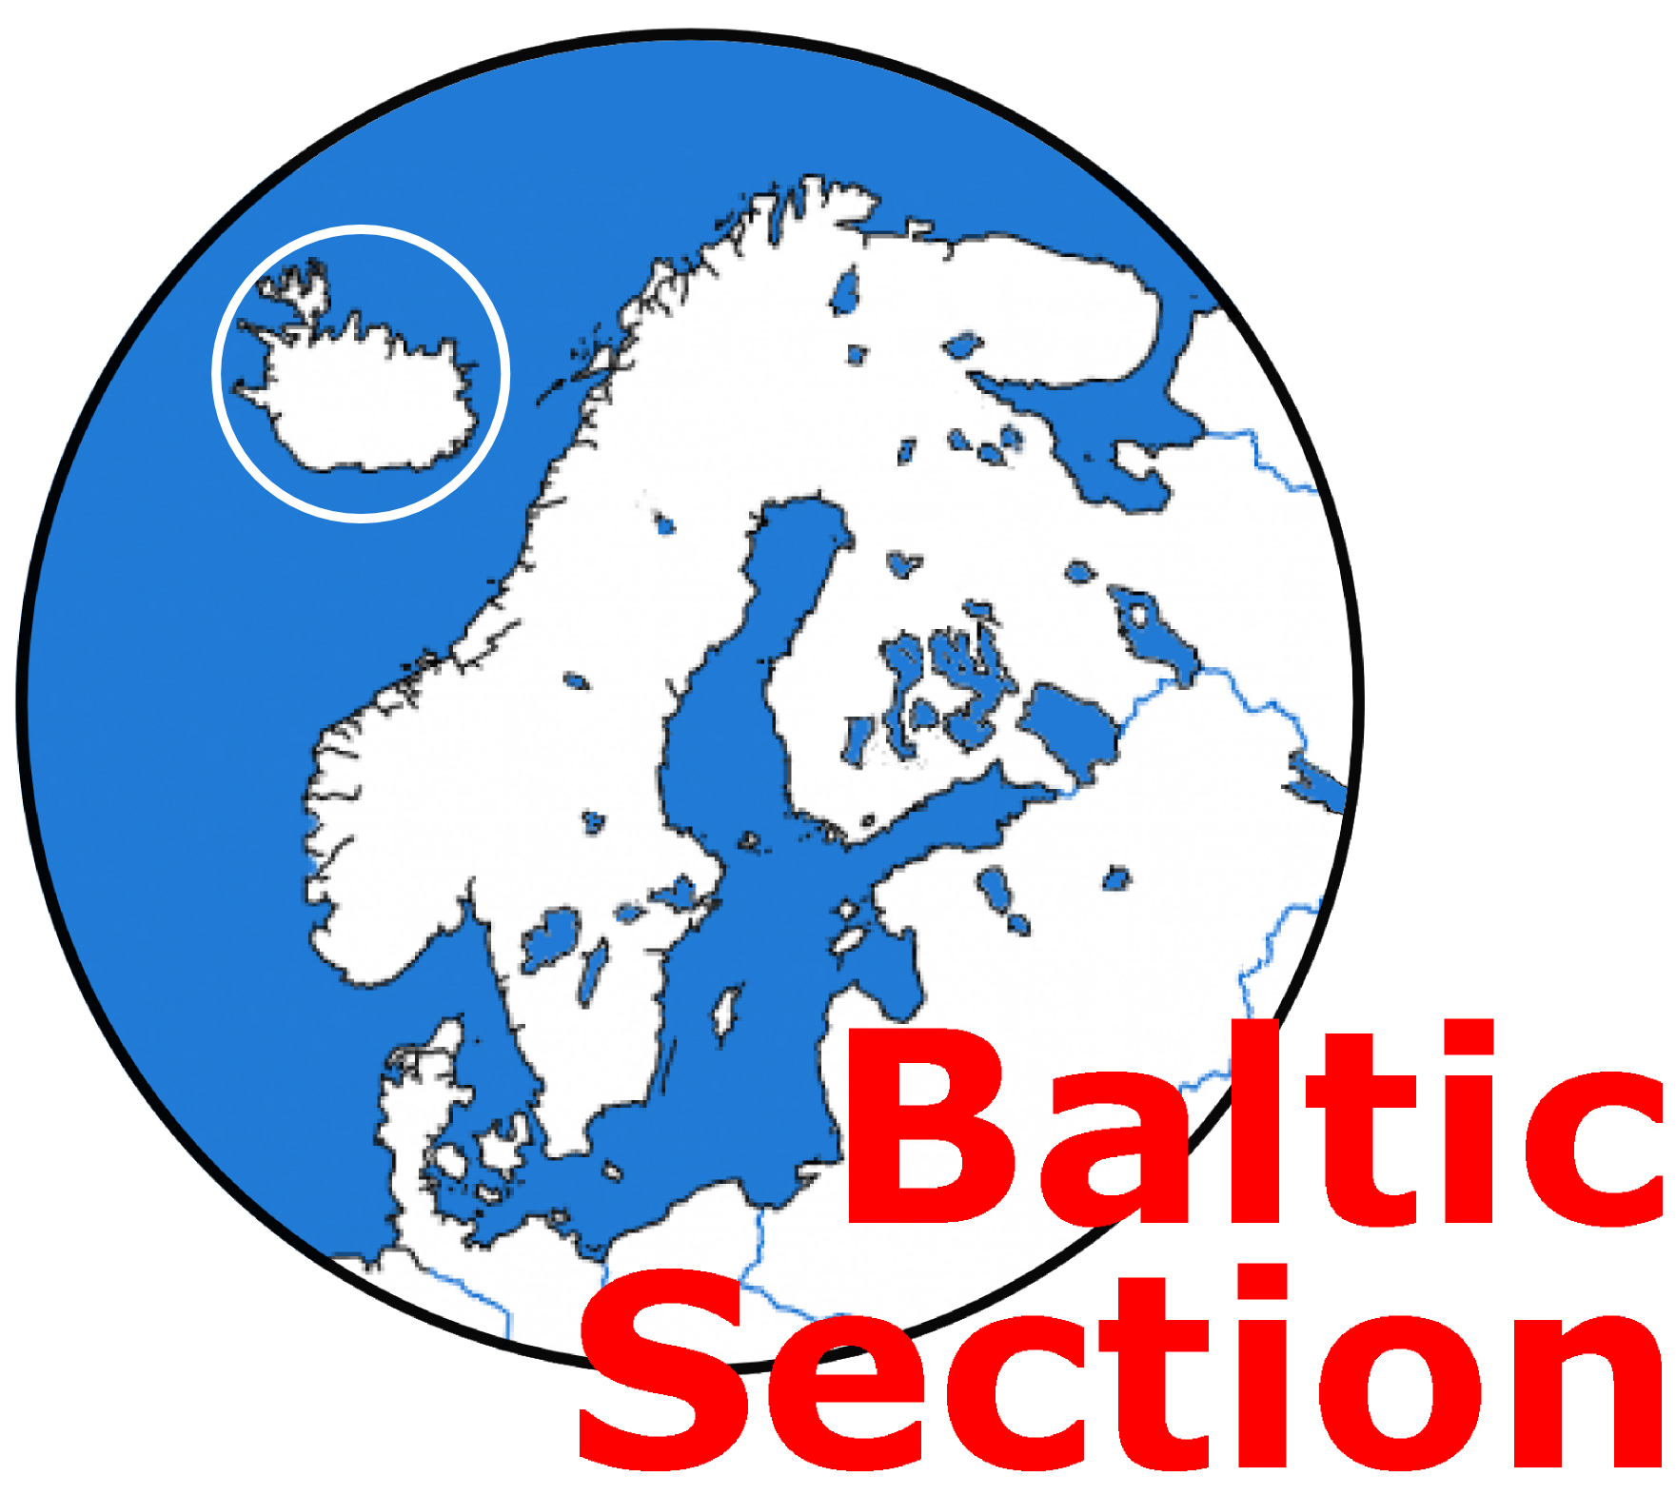

Saturday 10th February 2024
0930 to 1700

At CA House, 1 Northey Street, Limehouse Basin, London E14 8BT

An opportunity to find out all you need to know to sail the Baltic – especially aimed at first-time visitors, but also useful for those intending to explore further. Meet those already sailing the area, and let them share their knowledge and experiences with you.

The day's programme commences with Registration at 0930 (tea/coffee available) and includes:

Presentations on:
Routes to and from the Baltic
Baltic Cruising Information
Types of Mooring and Techniques
Overwintering
Using the CA website

Country-specific stalls and bring-and-buy sale - an opportunity to buy charts, pilots etc.

A light buffet lunch and tea/coffee (served on arrival and mid-afternoon) is included in the Seminar fee)

The bar will be open throughout the day for the purchase of alcoholic and non-alcoholic drinks. Evening meal. At the end of the Seminar members of Team Baltic sit down for a meal together. Everyone attending the Seminar is welcome to join us. A choice of meals will be available – order and pay at the bar on the evening (please indicate Yes or No on the booking form so we can advise the caterers of likely numbers).

The fee for CA Members is £20. The fee for Non-Members is £45. (the non-member portion of the fee (£25) will be refunded to anyone joining CA on the day or very shortly thereafter).

Booking forms must be received no later than Friday 2nd February.

(see Page 2 for Booking/Payment Form)
CA Baltic Seminar - BOOKING AND PAYMENT

Seminar Fees: (Booking Forms/Payment to be received no later than Friday 2nd February)
- CA Members - £20
- Non-members - £45 (see below for refund policy)

Non-members: the non-member portion of the fee will be refunded to anyone joining CA on the day – simply hand your fully completed CA Application Form and Direct Debit Instruction to CA Baltic Section Secretary, Fay Cattell on the day of the Seminar. (Refunds will be paid upon completion of the Membership Application process).

Please complete the Booking Form below, and return by email to: baltic@theca.org.uk or post to Fay Cattell, 31 Blackbrook Park Avenue, Fareham, Hants, PO15 5JN
to arrive no later than Friday 2nd February 2024
Enquiries: email to baltic@theca.org.uk or telephone 01329 284260 Mob 07702 989819.

________________________________________________________________________________

Baltic Seminar, Saturday 10th February 2024

Please book places for the following (£20 for CA Members; £45 for Non-CA members).

……………………………………………………………………………………………....

………………………………………………………………………………………………

Email address and telephone number of person making the booking:

………………………………………………………………………………………………………………………

PAYMENT
PAYMENT METHOD: Bank transfer / cheque (please delete as appropriate)
The preferred method of payment is by bank transfer (regret no credit cards). BACS details are as follows
Sort Code: 20-36-98
Account number: 20621196
Account name: Cruising Association Baltic Section
Please add booking member’s surname + SMR as the payment reference.

If you wish to pay by cheque please send a cheque (payable to Cruising Association – Baltic Section) with this form to Fay Cattell at the above address.

EVENING MEALS required? YES / NO (Note: evening meal is NOT INCLUDED in the Seminar Fee)

BRING AND BUY SALE: Members will have the opportunity to sell their used charts, pilot books, equipment on this day but must be prepared to conduct the sales themselves. Please complete below if you wish to bring items for sale. All transactions are private arrangements between individuals. No responsibility can be accepted by The Cruising Association.

I plan to bring the following items (i.e. charts, pilot books, equipment):

……………………………………………………………………………………………………… for sale on the day.

