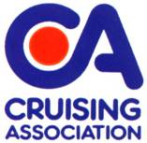
EAST COAST RALLY 22th-24th MAY 2015

TERMS AND CONDITIONS OF BOOKING
Vessels attending any CA Rally need to be covered by adequate third party and public liability insurance. Minimum £2,000,000 for any one accident;
The Event Organisers and Organising Body shall not be in any way liable for any loss, damage, death or personal injury howsoever caused to the owner, skipper, his/her crew or other persons on a boat, as a result of their taking part in the Meet, Rally or Cruise-in-Company. Moreover, every skipper/owner warrants the suitability of his/her yacht/boat for the Meet, Rally or Cruise-in-Company and that his/her boat is insured for taking part in the Meet, Rally or Cruise-in-Company;
When on a Meet, Rally or Cruise-in-Company with the CA the safety of any yacht/boat and her entire management including insurance shall be the sole responsibility of the owner/skipper who must ensure that the yacht/boat is fully found, thoroughly seaworthy and manned by a crew of sufficient number and experience who are physically fit to face bad weather. The owner/skipper must be satisfied as to the soundness of the hull, spars, rigging, sails and all other gear. He/she must ensure that all safety equipment is properly maintained, stowed and in-date and that the crew know where it is kept and how it is to be used.
PLEASE CONFIRM:
The vessel is insured with: ……………………………………………....................................................(name of company) and I have Third Party and Public Liability insurance cover of at least £2,000,000 for any one accident. My insured cruising range covers the area relevant to this event. I am aware that the Cruising Association and the Rally organisers accept no responsibility for the safety of my vessel, or its crew. The decision to sail and all handling of the vessel and its tender are the responsibility of the skipper who should take his decisions knowing the abilities of his vessel and of his crew. I confirm that by ticking the box below that I have read and agree to the General Conditions that apply to the CA Sections’ Rallies/ Meets and Cruises. Please tick the box:

Name of Skipper/Boat Owner: ……………………………………………………………
Signed:..........................................................................................................Date:...................................
(To be signed by the Skipper/Boat Owner)
Name of Boat:…………………………………………………………………………………..

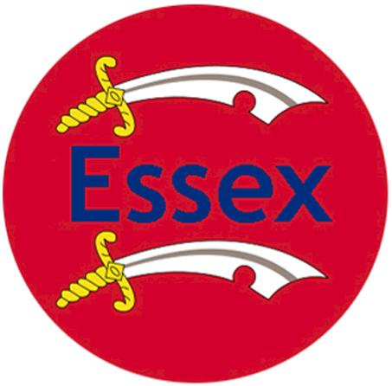
BOOKING FORM – Cruising Association East Coast Rally to the London River
22-24 May 2015 (Late Spring Bank Holiday weekend)

Please reply as soon as possible, but no later than 12 May 2015
Entries will not be accepted unless accompanied by a signed and dated Disclaimer

Member’s Name(s)……………………………………….......….. Tel No…………..............

Email …………………………….........................……………………………………………

Address (if not contactable by email): .............................................................................

Guests names (if applicable) ………………………………………………………………………………………………

Programme | Joining in | Notes | Total  due
Fri 22 May (eve)  Gather at Queenborough All-Tide  Pontoon. Informal supper ashore in a local  Pub | I will/will not be  attending  By boat/By land  No. of persons ______ | Pay mooring fee direct to Q’Boro  Harbourmaster. From £12 p/night  (Current price, may be subject to  change) | n/a
Sat 23 May Cruise in Company  up the London River to  Limehouse Basin Marina | I will/will not be  attending  No. of persons ______ | Pay mooring fee direct to Marina  £3.00 p/metre, p/night  (Current price, may be subject  to change) | n/a
Sat 23 May (eve) “Bring Your Own”  Pontoon Party/BBQ on the terrace at CA House | I will/will not be  attending  No. of persons ______ | We have arranged to use the  terrace to cook our own food  using CA Bar’s BBQ.  The bar will also be open | n/a
Sun 24 May (day) Visit to historic  Greenwich. | I will/will not be  attending  No. of persons ______ | Travel by public transport (DLR  or river taxi)  Any fees paid locally | n/a
Sun 24 May (eve) Dinner at CA House,  6.30pm for 7.00pm. Please choose from  the enclosed menu | I will/will not be  attending | No. of persons____ | £______

I require a Marina Berth at Limehouse Basin for the nights of:
Friday 22nd Saturday 23rd Sunday 24th (please tick)

Boat Details:
Name.....................................................................................................................................
Class………………………..LOA……………….Beam………………….Draft…………………
Berths outside CA House in Limehouse Basin Marina, London, E14 8EG. Tel 020 7308 9930. We will confirm your booking with the Marina so we can berth together during the weekend but please settle your berthing fee directly with the marina. Please contact the Marina office direct if you wish to arrive early or stay longer.
Not coming by boat but want to stay at CA House? We have reserved all the cabins at CA House on 23rd and 24th May. If you wish to book a cabin you should contact CA House office direct. Please tell them that you are part of the East Coast Rally when booking.

East Coast Rally Dinner at CA House, Sunday 24th May
Three course dinner, COST £25.00 PER PERSON (please add £3.00 extra if you choose the Main courses with *)
Please indicate numbers for each option & any special dietary requirements. After dinner tea or coffee is included in the price.
NAME:
PHONE NUMBER:
STARTERS | name |  | name | Name | name
Selection of herring fillets
Smoked salmon on green salad
“Tricolore” Mozzarella, Tomato, Basil
MAIN COURSE
Beef bourguignon, Potatoes & Veg
Chicken breast baked with mushroom, onion, mayo & cheese , Potatoes & Veg
Beef lasagne with Salad
Mushroom stroganoff with Rice (V)
Lamb shank with Mashed potato & Veg
(* £3.00 extra)
Salmon fillet with potato salad & Veg (*£3.00 extra)
DESSERT
Cheese & Biscuits
Vanilla Cheesecake with fruit compote

Please send your completed form to Essex Section Treasurer, Peter Barnard
By post to: “Beaumont”, Queens Street, Fyfield, Essex, CM5 0RY.
By E-mail: peterb123@tiscali.co.uk Tel: 01277 899233

*I enclose a Cheque / Bank transfer for £____________.________
(CHEQUE PAYABLE TO: CRUISING ASSOCIATION – ESSEX SECTION)

For those wishing to use online transfer the bank details are as follows:
Bank: NatWest Sort Code: 60-22-06 Account No. 96421053

*Please indicate preferred option.

If you have any questions or need further information about the rally please contact joint Essex Section Secretaries:
Ray and Suzanne Kay
Tel: 07771 717935
Email: essex@theca.org.uk or suzannekay16@gmail.com

