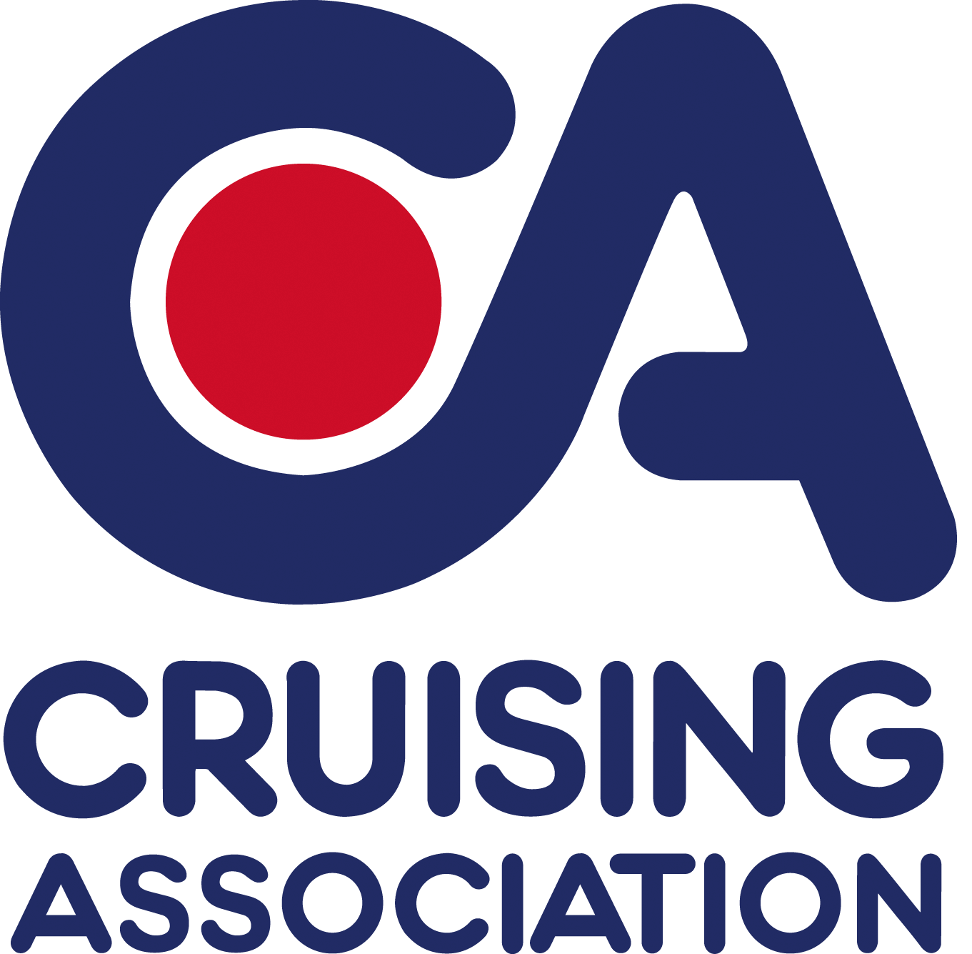 | CA Kent Section  August Bank Holiday Rally  North Fambridge Yacht Station  Saturday 27th – Monday 29th August  Booking Form

Skipper/Contact Name

Telephone:

Email
(or Address if not contactable by email)

Boat Name

Length (LOA)

I require a pontoon berth for the nights of: Please tick
Friday 26th August ……….
Saturday 27th August ……….
Sunday 28th August ……….
Supper at The Ferry Boat Inn on Sunday 28th August: Number of persons ……….
(Awaiting details of meal choices and prices)
I confirm that my vessel is insured and I have public liability insurance of at least £2,000,000 for any one accident
Signed ...........................................

Vessels attending CA Rallies and events
The Event Organisers and Organising Body shall not be in any way liable for any loss, damage, death or personal injury howsoever caused to the owner, skipper, his/her crew or other persons on a boat, as a result of their taking part in the Event and that his/her boat is insured for taking part in the Event. Vessels attending any CA Rally need to be covered by adequate third party and public liability insurance, minimum £2,000,000 for any one accident;
When on a Rally with the CA, the safety of any boat/yacht and her entire management including insurance shall be the sole responsibility of the owner/skipper, who must ensure that the boat/yacht is fully sound, thoroughly seaworthy and manned by a crew of sufficient number and experience, who are physically fit to face bad weather. The owner/skipper must be satisfied as to the soundness of the hull, spars, rigging, sails and all other gear. He/she must ensure that all safety equipment is properly maintained, stowed and in-date and that the crew know where it is kept and how it is to be used.
For further information please contact the rally organisers:
Sue and David Long
Email: davidlong354@gmail.com
Tel: 01622 746376 Mobile: 07821 774876

