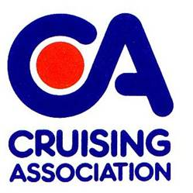
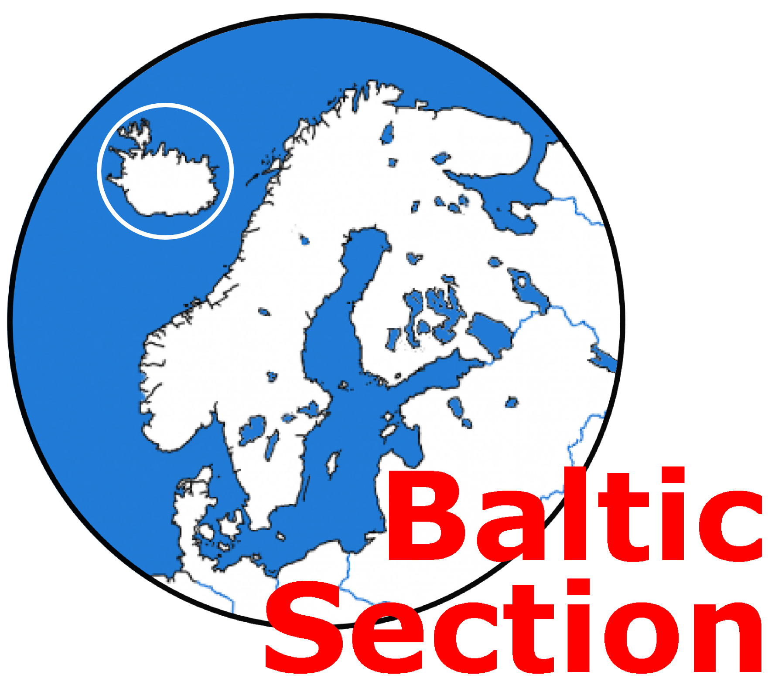
DENMARK INFORMATION DAY
Saturday 16th November 2019
1100 to approx. 1530

At CA House, 1 Northey Street, Limehouse Basin, London E14 8BT

Presentations will feature many aspects of sailing in this country, including getting there, preparations before you leave and what to expect when you are there. Principal speaker: Nicholas Hill, supported by a number of other experienced Denmark and Baltic sailors.

Admission: CA members no charge for the Information Day. Lunch £14 if required.
Non CA members £15 each for the Information Day plus £14 for lunch if required i.e. £15 or £29
(The non-member portion of the fee will be refunded to anyone joining CA on the day or very shortly thereafter).
Please complete the Booking Form below and return by email to: baltic-treasurer@theca.org.uk or by post to: Robin Pudney at 35 Rogers Mead, Hayling Island, PO11 0PN and make payment (if necessary) as follows. Please Note the form is required whether or not any payment is due.
The preferred method of payment is by bank transfer (regret no credit cards). BACS details are as follows
Sort Code: 20-36-98
Account number: 20621196
Account name: Cruising Association Baltic Section
Please add booking member’s surname + DEN as the payment reference.

If you wish to pay by cheque please send a cheque (payable to Cruising Association – Baltic Section) with this form to the Baltic Section Treasurer at the above address.
__________________________________________________________________________

Denmark Information Day, Saturday 16th November 2019

Please book places for the following

Name | CA Member Free | Non CA member  £15 | Lunch Required  £14  (pl. indicate any dietary requirement) | Total £
Total payment |  |  |  | £

Email address and telephone number of person making the booking:

………………………………………………………………………………………………………………………

