ESSEX SECTION 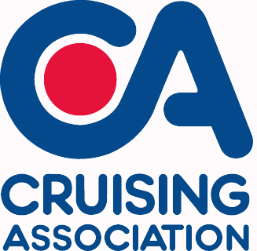

Booking Form
Talk and supper at Blackwater Sailing Club 4th February 2017
Please reply to Peter Barnard, Treasurer: peterb12360@gmail.com

Menu – Please indicate names for each option.

COURSE | Name | Name | Name | Name
Main Course
Catalan beef Casserole
Or:
Spiced blackened salmon

Or:
Stuffed chicken thighs with lemon sauce
Or:
Nut roast (v)
Dessert
Toffee Pudding
Or:
Apple frangipani tart
Please calculate your costs below for the event
Member(s) of the C.A. or BSC | Numbers for meal and talk@ £13.00 each…… | Numbers for talk only @ £3.00 each…….. | Total Cost:  £________
Non-member(s) of the C.A. or BSC | Numbers for meal and talk@ £15.00 each…… | Numbers for talk only @ £5.00 each…….. | Total Cost:  £________
Please indicate which one of the following payment options you prefer:
☐I have sent a cheque for £____.____ (cheque payable to: Cruising Association – Essex Section)
to Essex Sec. Treasurer, Peter Barnard, Beaumont, Queen Street, Fyfield, Essex, CM5 0RY.
☐I prefer using online transfer and will transfer the following amount £____.___
Online transfer the bank details are as follows: Bank- NatWest, Sort Code- 60-22-06, Account No.- 96421053.
Please also provide the following details:
Name:
Phone:
E-mail:
Last booking date Tues 31st January 2017

