
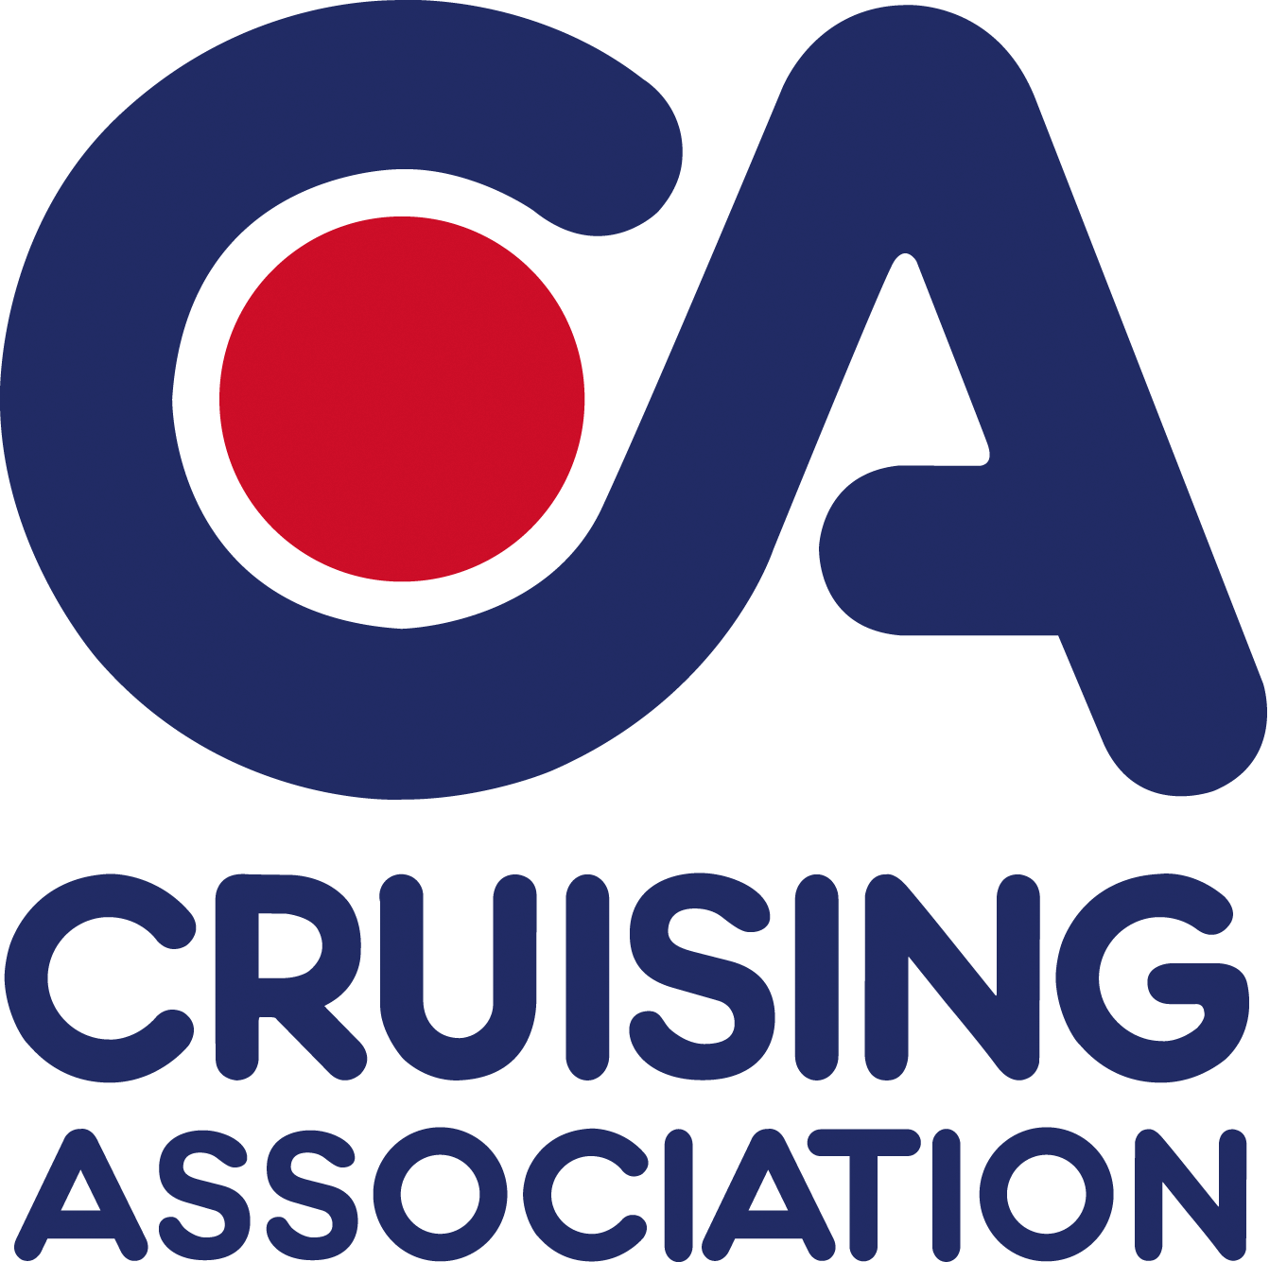
CA House,1 Northey Street
Limehouse Basin, London E14 8BT

Please reply to
Joint Section Secretary:
Judi King,
2 St James’s Street
Portsmouth
PO1 3AP
Tel: +44 (0)7734236075
E-mail: eastmidlands@theca.org.uk

CA East Midlands Section

Cruising Association East Midlands Section Meeting

Cruising Day Seminar

Saturday 14 November 2015
10.30 am to 4.00 pm
(in the function room)
Royal Oak, Kirby Muxloe
Leicester, LE9 2AN

Meeting charge £3.00 per person (£5.00 for non-members)
To pre-book your lunch see the separate menu attachment. The pub is happy to give the Early Bird offer of 2 courses for £13.95 for pre-booked meals for this lunchtime meeting. Please give your choices below or email them to eastmidlands@theca.org.uk . Pay on the day.

…………………………………………………………………………………………………………………

Booking form CA East Midlands Section

For Saturday 14 November 2015

Please reply by email to eastmidlands@theca.org.uk
or text to 07734 236075
or post to J King, 2 St James’s Street, Portsmouth, PO1 3AP
Member’s Name
Main contact phone: Main contact email:
Please book ..….. places for CA East Midlands Section meeting on Saturday 14 November 2015
My/Our Menu choices are: (Continue overleaf if necessary)

