
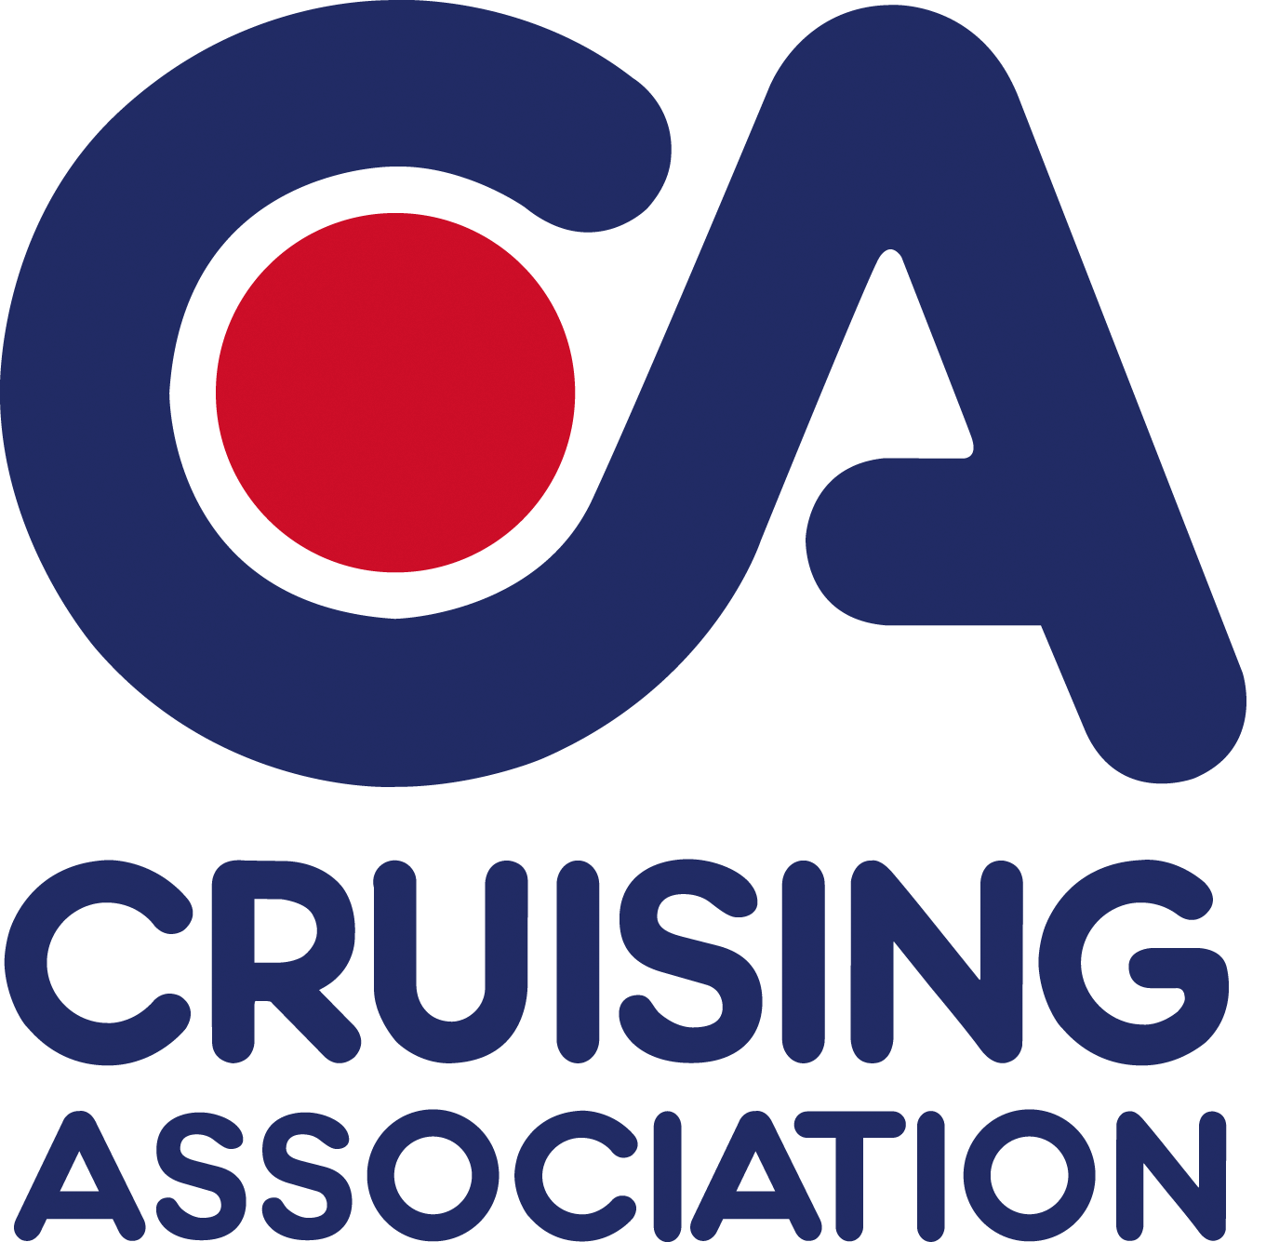
CA House,1 Northey Street
Limehouse Basin, London E14 8BT

Please reply to
Tony Montgomery-Smith
The Boathouse
Green Lane
Wyton
Huntingdon
PE28 2AP

0790 8644320
E-mail: eastmidlands@cruising.org.uk

CA East Midlands Section

Cruising Association East Midlands Section Meeting

Lunch-time meeting

Saturday 9 February 2013
11-00 am to 4.00 pm
Houghton Chapel, Houghton
Huntingdon, PE28 2AY

Pre-lunch Speaker
Frank Singleton - Understanding about and using Weather Forecasts
Afternoon speakers, Ted Wilson -preparing to cross the Atlantic,
Peter Jones, and James Collier, who sailed to the Arctic last summer.

Meeting charge £3.00 per member £5.00 for non-members
Please pre-order lunch from the menus (separate attachment).

………………………………………………………………………………………(or use email)

Booking form CA East Midlands Section meeting 9 February 2013
Please reply by Monday 4 February 2013 to eastmidlands@cruising.org.uk
Member’s Name (1)
Carvery (@£7.00) if available:
Otherwise Menu choices:
Member’s Name (2)
Carvery (@£7.00) if available:
Otherwise Menu choices:
Main contact phone:
Guest Name (1)
Carvery (@£7.00) if available:
Otherwise Menu choices:
Guest Name (2)
Carvery (@£7.00) if available:
Otherwise Menu choices:

