
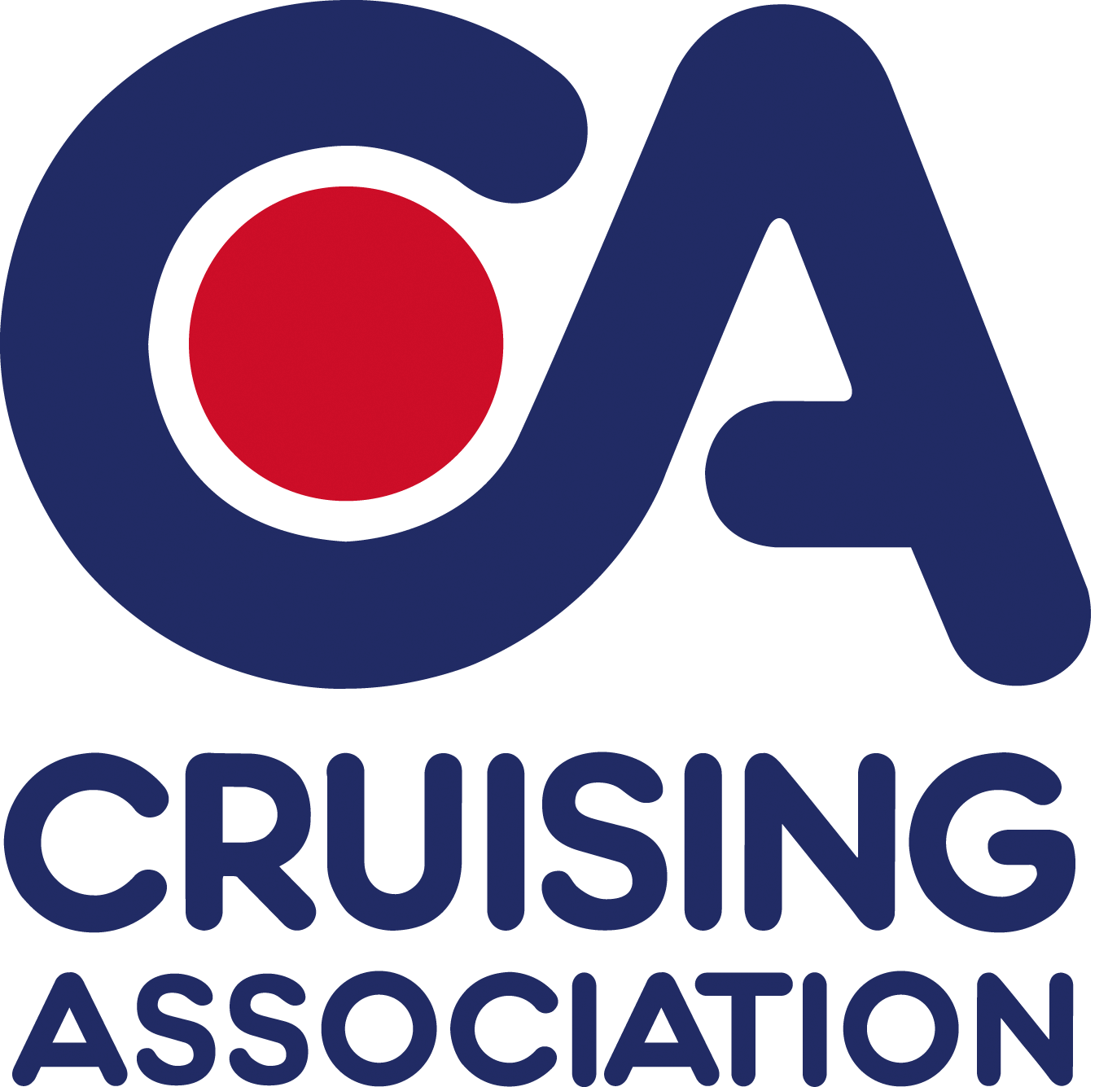
CA House,1 Northey Street
Limehouse Basin, London E14 8BT

Please reply to
Joint Section Secretary:
Judi King, High House
Lutterworth Road Walcote
Lutterworth LE17 4JW
Tel: +44 (0)1455 552413
E-mail: eastmidlands@cruising.org.uk

CA East Midlands Section

Cruising Association East Midlands Section Meeting

Laying-Up Lunch

Saturday 30 November 2013
10.30 am to 4.00 pm
Royal Oak, Kirby Muxloe
Leicester, LE9 2AN

Pre-lunch Speaker
The Story of Navigation: 2000 BC to 2020 AD
– a talk by Jeremy Batch

Meeting charge £3.00 per member £5.00 for non-members
Menus to pre-book your lunch will be sent out shortly

……………………………………………………………………………………………………………………

Booking form CA East Midlands Section meeting 30 November 2013
Please reply by Monday 4 November to eastmidlands@cruising.org.uk or tel: 07734 236075
Member’s Name (1)
Main contact phone:
Main contact email:
Please book ………….. places for CA East Midlands Section meeting on Saturday 30 November 2013
I am willing to give a short presentation on a cruise in the (please state area) ………….……………….

