
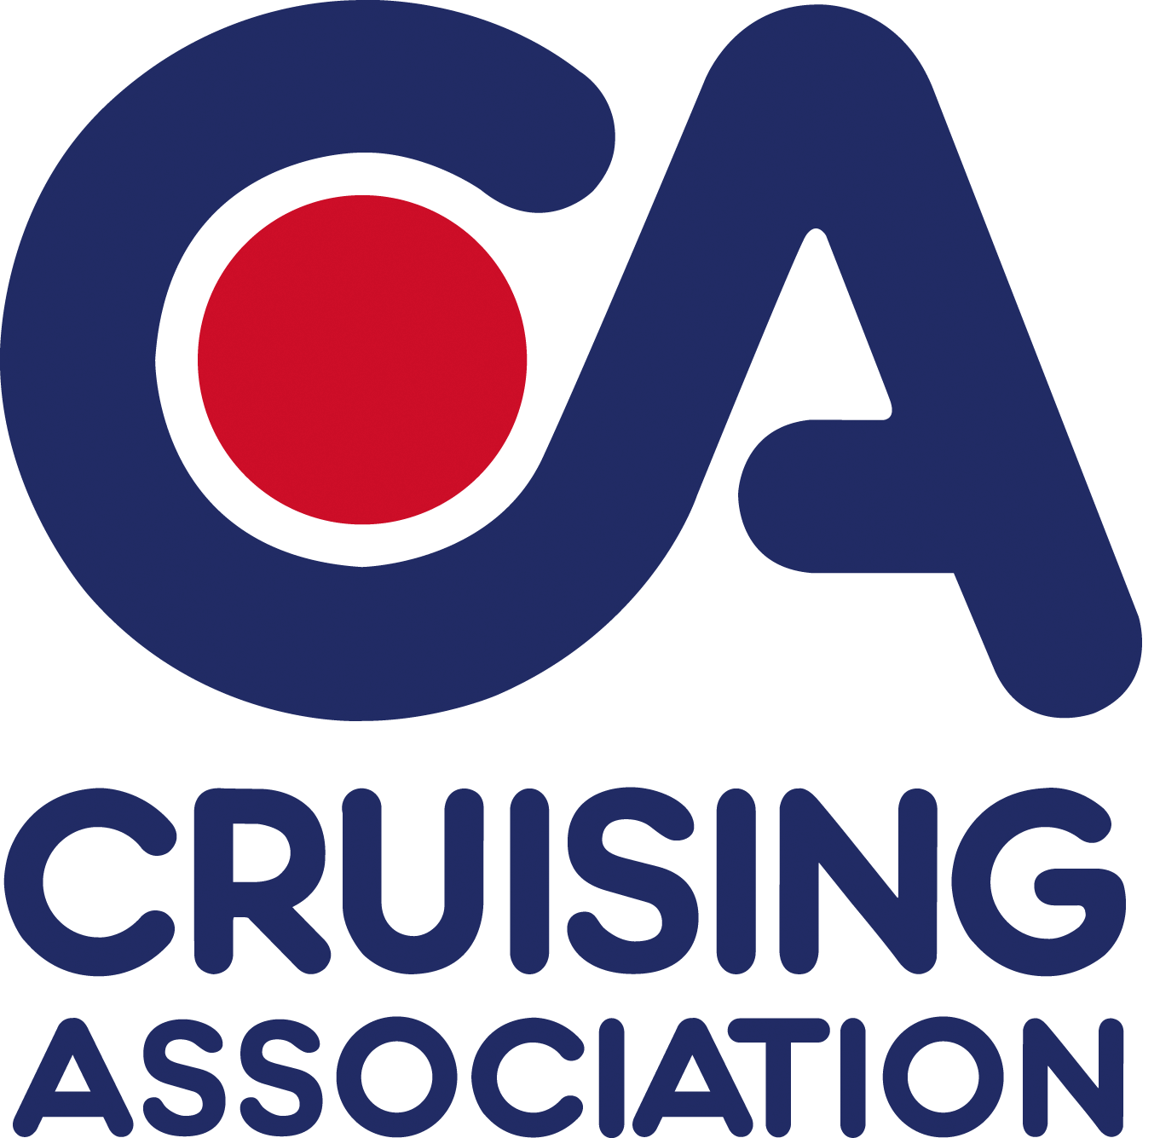

CA House
1 Northey Street
Limehouse Basin
London E14 8BT

Please reply to
Joint Section Secretary:
Judi King, High House
Lutterworth Road Walcote
Lutterworth LE17 4JW

Tel: +44 (0)1455 552413
E-mail: eastmidlands@cruising.org.uk

CA East Midlands Section

Cruising Association East Midlands Section Meeting

Saturday 22 January 2011

Speaker - Willie Wilson - Managing Director of Imray Charts and Books

The Gliding Centre

Husbands Bosworth Airfield, Leicestershire, LE17 6JJ

7.30 for 8.00 p.m.

Bar available. Gliding club canteen will be open until 8.00 p.m. for snacks and light meals.
Please note there will be a small charge of £3.00 for non-CA members.

……………………………………………………………………………………………………………………

Booking form

I will be attending the CA East Midlands Section meeting on 22 January 2011

Name:

Address:

Phone:
Email:

Please reply by Friday 14 January 2011 to eastmidlands@cruising.org.uk

