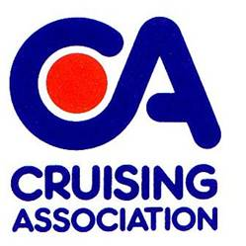
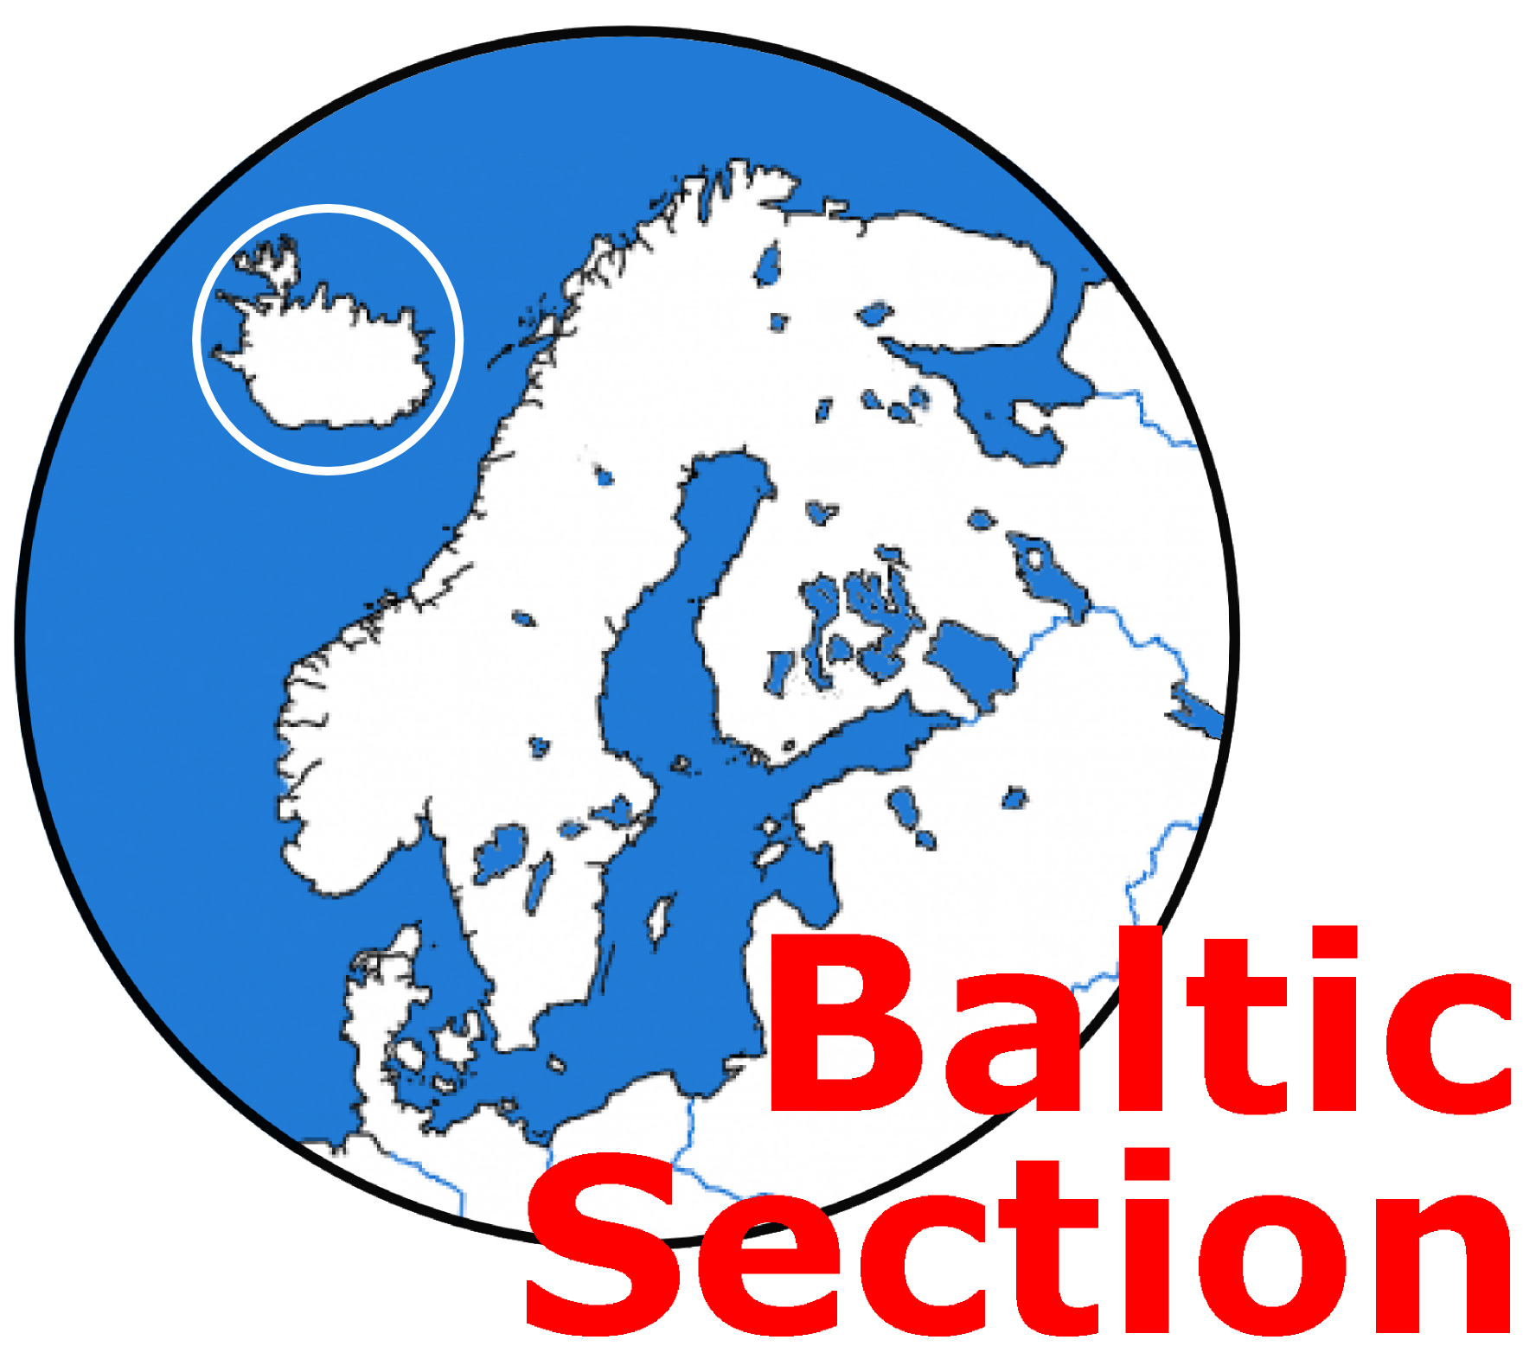
ICELAND, GREENLAND, FAROES, JAN MAYEN INFORMATION DAY
Saturday 7th March 2020
1100 to approx. 1545
At CA House, 1 Northey Street, Limehouse Basin, London E14 8BT

Principal speaker: Michael Henderson together with experienced Arctic and Northern Waters sailors Helen Gould and Alasdair Flint.

Have you thought about a great exploration? Whether you are intending to sail to these waters and want to learn all you need to know or would like to enjoy seeing nature in its raw beauty but from the comfort of a chair in CA's Assembly Room - this is the day for you. EVERYONE WELCOME.

Admission: CA members no charge for the Information Day. Lunch £14.50 if required.
Non CA members £15 each for the Information Day plus £14.50 for lunch if required i.e. £15 or £29.50
(The non-member portion of the fee will be refunded to anyone joining CA on the day or very shortly thereafter).
PLEASE NOTE – prior booking and payment necessary. A booking form is required whether or not any payment is due.
Please complete the Booking Form below and return by email to: baltic-treasurer@theca.org.uk or by post to: Robin Pudney at 35 Rogers Mead, Hayling Island, PO11 0PN and make payment (if necessary) as follows.
The preferred method of payment is by bank transfer (regret no credit cards). BACS details are:
Sort Code: 20-36-98. Account number: 20621196 Account name: Cruising Association Baltic Section
Please add surname + ICE as the payment reference.

If you wish to pay by cheque please send a cheque (payable to Cruising Association – Baltic Section) with this form to the Baltic Section Treasurer at the above address.
__________________________________________________________________________

Iceland/Greenland Information Day, Saturday 7th March 2020

Please book places for the following
Name | CA Member Free | Non CA member  £15 | Lunch Required  £14.50  (pl. indicate any dietary requirement) | Total £
Total payment |  |  |  | £
Email address and telephone number
of person making the booking:………………………………………………………………………..……………………

