South West Section
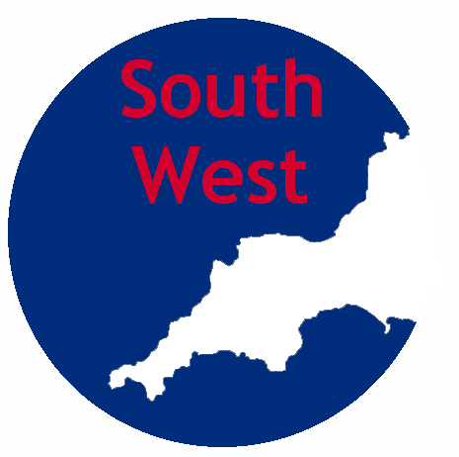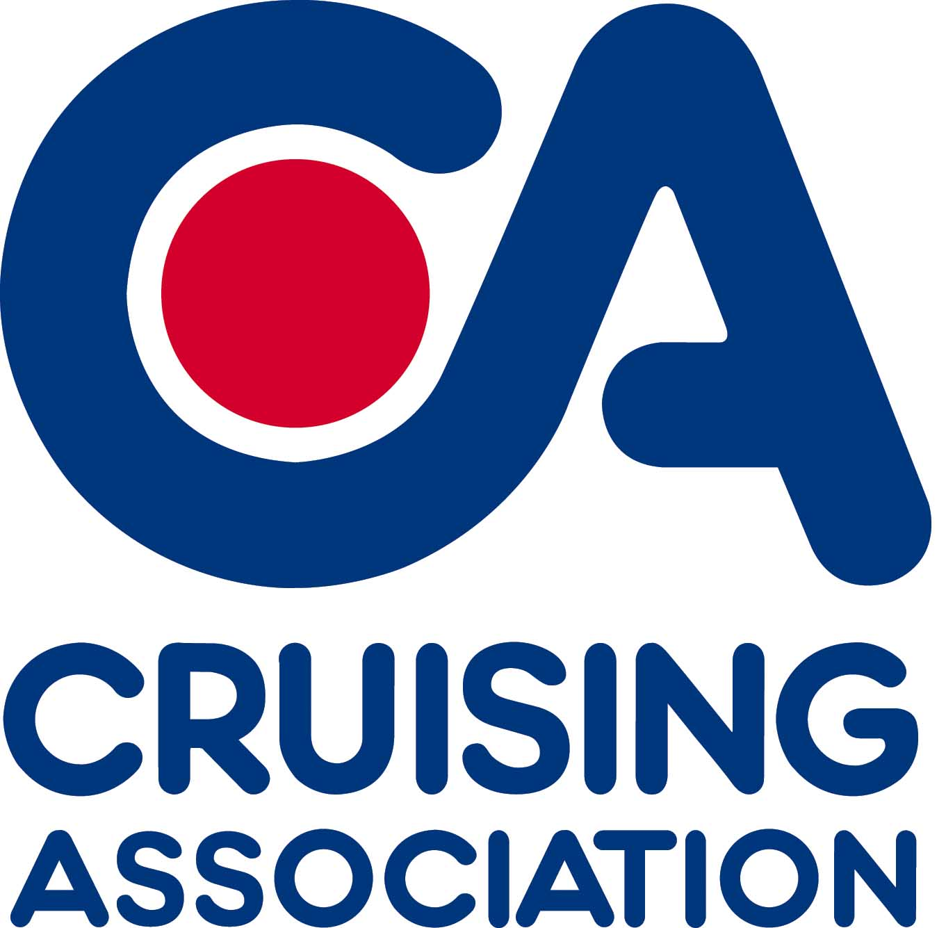
Eminent Speaker; Saturday November 12th 10.45 – 15.00
Paul Heiney; A Lifelong Love Affair with the Sea, on Saturday November 12th, 11.00.to 15.00 at Liskeard Public Hall, West Street, Liskeard, PL14 6 BW

Dear SW Section Member,
As you will know from the September Newsletter we have a rather special treat for us all next month, we are very pleased to say that for our first event of the winter season we have a rather eminent speaker, Paul has given the Hanson Lecture at CA House and has spoken to several other Sections, we are very glad he is willing to travel west by train not sea this time!

Paul is a long time member of the CA, writer, broadcaster and sailor of more than 30 years, Paul participated in 2003 Azores and Back Race single-handed as well as the Singlehanded Transatlantic Race in 2005 in a Victoria 38. In 2011/12 he fulfilled a dream, he undertook the long trek to Cape Horn, at the southernmost tip of South America, remote and inhospitable, this is the ultimate seafarer’s destination: the sailor’s equivalent of scaling Mount Everest, he will be talking about his experiences of off shore and ocean cruising.
We will start with coffee and biscuits at 10.45 am, the talk will be from approximately 11.15-12.30, lunch will be provided by Delicious Delights and will be delicious, we will have the second part of the talk and questions from 13.30-14.45, we will close at 15.00, the cost will be £15.00pp. At some point there will be a brief discussion about the SW and Lyme Bay Sections.
---------------------------------------------------------------------------------------------
To book please email southwest@theca.org.uk or ring Jill Trew 01579 386939 or 07818 002624, please give the following information;
- Names of those booking for the talk and lunch.
- Contact details, email / phone
- Choice of food for each person.
Beef Casserole (gluten free) or
chicken and Leek Pie or
Spicey Vegetable and bean casserole.
Lemon meringue roulade (gluten free) or
Banoffee Pie.
- Any special dietary requirements not covered by the above.
Please pay £15.00 per person by bank transfer to Acc no. 58018409 sort code 60-21-37 giving the reference ‘PH Talk’, or by cheque payable to ‘Cruising Association Southwest Section’ to 18 Menabilly Close, Callington, Cornwall, PL17 7TJ.
-----------------------------------------------------------------------------------------
Looking forward to seeing you there! Jill, the SW Section Committee!

