EAST COAST ESSEX SUMMER RALLY
Burnham-on-Crouch
24th-26th August 2013

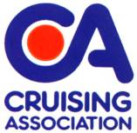
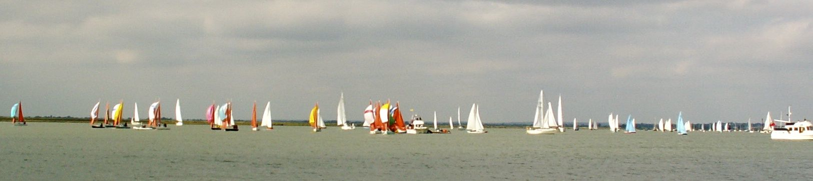
You are invited join in the fun of Burnham Week, during it’s first weekend, with an informal rally, featuring some cruising, some activities ashore and afloat, and to eat, drink and have fun with friends old and new.

Berths have been provisionally booked at Burnham Yacht Harbour Burnham-on-Crouch, Essex CMO 8BL Tel: (0)1621 782150 http://www.burnhamyachtharbour.co.uk . We will confirm your berth booking with the marina, but please settle your berthing fee directly with the Harbour Master.
Entry to all Burnham Yacht Clubs is open to CA members but you may need to book some social events with the appropriate club.
All CA members and their friends are welcome, with or without boats.
Caravans and Campervans can be accommodated.
All-in charge for the Rally Dinner includes
three course meal.
Programme
Saturday 24th August (HW Burnham: 15:30 BST, spring tide)
(HW Whitaker Beacon: 15:10 BST, spring tide)

Arrival and berthing - call Harbour Master on VHF Channel 80 stating you are attending CA Rally. John & Penny Blakesley will try to be around to take your lines if needed.
Afternoon: Options to visit the Yacht Clubs or view the racing (Burnham week website)
Evening: Pontoon Party (bring glasses, nibbles and a bottle).
Sunday 25th August

am/pm: Option to view racing afloat. Plans for Sweet Surrender and Patchwork to anchor near the action for a picnic lunch and view the racing – bring your own lunch and drinks.
7:30 for 8pm Meet for drinks and introductions at the Swallowtail Restaurant for a
Three Course Dinner (see attached menu & booking form)

Monday 26th August (HW Burnham: 16:40 BST) (HW Whitaker Beacon: 16:20 BST)

Morning: Tea and coffee on each other’s boats or at the Swallowtail from 11am
Racing and entertainment continue in Burnham including “Quay Day” which includes a number of stalls on the quayside from 10am to 5pm.
Burnham Week, of course, continues until 31st August
EAST COAST CA RALLY 24th-26th August 2013 – TERMS AND CONDITIONS OF BOOKING
Vessels attending any CA Rally need to be covered by adequate third party and public liability insurance. Minimum £2,000,000 for any one accident;
The Event Organisers and Organising Body shall not be in any way liable for any loss, damage, death or personal injury howsoever caused to the owner, skipper, his/her crew or other persons on a boat, as a result of their taking part in the Meet, Rally or Cruise-in-Company. Moreover, every skipper/owner warrants the suitability of his/her yacht/boat for the Meet, Rally or Cruise-in-Company and that his/her boat is insured for taking part in the Meet, Rally or Cruise-in-Company;
When on a Meet, Rally or Cruise-in-Company with the CA the safety of any yacht/boat and her entire management including insurance shall be the sole responsibility of the owner/skipper who must ensure that the yacht/boat is fully found, thoroughly seaworthy and manned by a crew of sufficient number and experience who are physically fit to face bad weather. The owner/skipper must be satisfied as to the soundness of the hull, spars, rigging, sails and all other gear. He/she must ensure that all safety equipment is properly maintained, stowed and in-date and that the crew know where it is kept and how it is to be used.

PLEASE CONFIRM:
The vessel is insured with: ……………………………………………....................................................(name of company) and I have Third Party and Public Liability insurance cover of at least £2,000,000 for any one accident. My insured cruising range covers the area relevant to this event. I am aware that the Cruising Association and the Rally organisers accept no responsibility for the safety of my vessel, or its crew. The decision to sail and all handling of the vessel and its tender are the responsibility of the skipper who should take his decisions knowing the abilities of his vessel and of his crew. I confirm that by ticking the box below that I have read and agree to the General Conditions that apply to the CA Sections’ Rallies/ Meets and Cruises.
Please tick the box;

Signed:..........................................................................................................Date:...................................
To be signed by the Skipper/Boat Owner

BOOKING FORM - East Coast Summer Rally
Saturday 24 August – Monday 26th August 2013 (Bank Holiday weekend)
Please return as soon as possible, but not later than 12/08/13
I wish to attend the Rally at the Burnham Yacht Harbour, Burnham on Crouch, Essex.
Entries will not be accepted unless accompanied by a signed and dated Disclaimer Form.

Name……………………………………….......….. Tel No…………...............……………

Email Address…………………………….........................………………………………….

Address (if not contactable by email): .............................................................................

……........................................................................
I require a Marina Berth for the nights of:
Friday…….. Saturday…….. Sunday…….. Monday…….. please tick.
Boat Details:
Name.....................................................................................................................................
Class………………………..LOA……………….Beam………………….Draft…………………

Berths have been provisionally booked at Burnham-Yacht-Harbour Burnham-on-Crouch, Essex CMO 8BL Tel: (0)1621 782150 .http://www.burnhamyachtharbour.co.uk . We will confirm your berth booking requirements with the Harbour Master, but please settle your berthing fee directly with the marina.

Please Forward Completed Form To: Essex Section C.A. Treasurer, Peter Barnard, “Beaumont”, Queens Street, Fyfield, Essex, CM5 0RY.
E-mail: peterb123@tiscali.co.uk Tel: 01277 899233

Essex Section Cruising Association Menu for Rally Supper Sunday 25th August 2013 at the Swallowtail, Burnham Yacht Harbour
Please select what you & your crew/family would like to eat, & return the booking form with your choices to Peter Barnard no later than 12/8/2013
Starters
Broccoli & Stilton Soup topped with Croutons
Served with crusty bread

Classic Insalata Caprese Salad (V)
Served with mixed leaves

Smoked Salmon Platter
Dressed with chopped capers & dill pickle

Mains
Corn Fed Chicken
Served with a white wine, bacon, mushroom & cream sauce

Homemade Smokie Fish Cakes
Served with a sweet chilli dip

Pork Chop marinated in apples & cider
Served with a mustard cream sauce

Wild Mushroom & Red Onion Gratin (V)

Desserts
Belgian Waffles served with Rum & Raisin Ice Cream

Fresh Lemon Tart served with Raspberry Sorbet

Rich Chocolate Torte served with Clotted Cream

Cheese Board

-----------

Coffee/Tea and mints

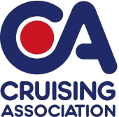 | Essex Section Summer Rally Dinner  Sunday 25th August 2013 - 7:30pm For 8pm  Swallowtail, Burnham Yacht Harbour, Burnham-On-Crouch | 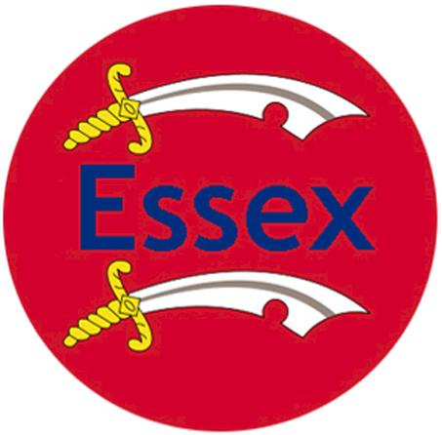
Booking Form
Name : ………………………………………………………… Contact Tel No ……………………………………. Email …………………………………
Please Forward Completed Form To: Essex Section C.A. Treasurer, Peter Barnard, “Beaumont”, Queens Street, Fyfield, Essex, CM5 0RY.
E-mail: peterb123@tiscali.co.uk Tel: 01277 899233
Menu – Please indicate numbers for each option & any special dietary requirements. The Main is served with a selection of seasonal vegetables. After dinner coffee and mints are included in the price.
COURSE | Name | Name |  | Name | Name
STARTERS
Broccoli & Stilton Soup
Classic Insalata Caprese Salad (V)
Smoked Salmon Platter
MAIN COURSES
Corn Fed Chicken
Homemade Smokie Fish Cakes
Pork Chop Marinated in Apples & Cider
Wild Mushroom & Red Onion Gratin (V)
DESSERT
Belgian Waffles
Fresh Lemon Tart
Rich Chocolate Torte
Cheese Board
PLEASE BOOK BY 12/08/2013
Please calculate your costs below for the event
Number attending…… | Dinner @ £26.95 each | Total Cost: £________
Please indicate which one of the following payment options you prefer:
I enclose a cheque for £____.____ (cheque payable to: Cruising Association – Essex Section). I prefer using online transfer and will transfer the following amount £____.___
For online transfer the bank details are as follows:
Bank: NatWest Sort Code: 60-22-06 Account No. 96421053.

