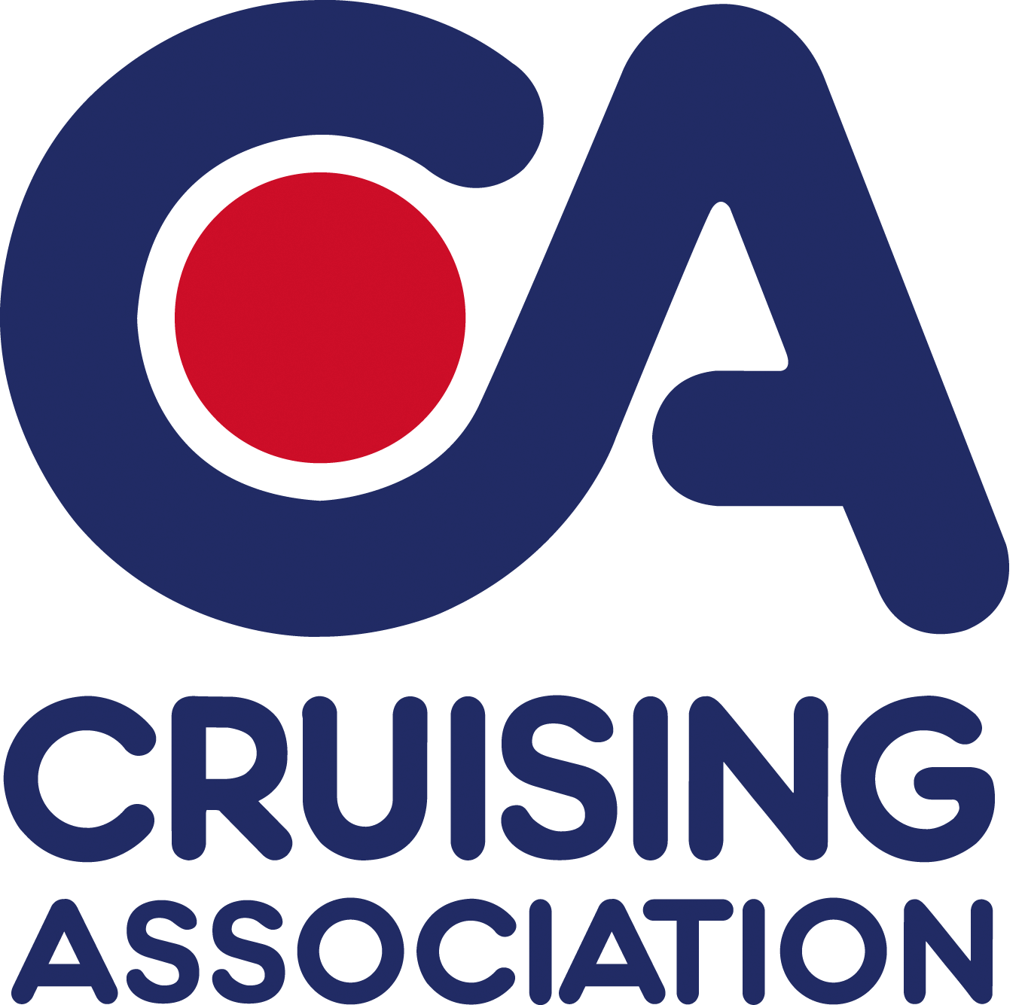

Cruising Association South West Section
Summer 2013 Rally May 31st to June 2nd
River Fal and Truro River

We are holding another rally again in the Fal so make the sun shine this time and come and join us!

Organiser(s):Jill and Frank Trew with Peter and Sue Maude and Peter Louth
Phone; (home) 01579 382451 until May 14th. Mobile: 07818 002624
Email: dennjord@yahoo.co.uk
Host Boat Name: Den Njord (Westerly Conway, ketch)

The Rally will begin on Friday May 31st in the Truro River with a pontoon Party on the Ruan pontoon, just up-stream from Smugglers, starting at 18.00, arrive during the afternoon for an explore of the area by tender, a short walk ashore, or lunch/cream tea at the Smugglers Cottage on the way. After drinks and nibbles supper can be cooked aboard or bring the barbeque as the pontoon has a concrete area at the southern end and we can share food to eat in our cockpits.

On the 1st June we will sail to Mylor Marina still on the Truro River, they have excellent facilities, there are shops in the village of Mylor Bridge a very pleasant walk inland, and a coastal walk to Flushing or a visit to Trelissick Gardens is possible on the way. In the evening we will be eating ashore in Castaways restaurant, we will be negotiating a price for our meal with them when we are clearer about the numbers attending.

On the 2nd June some will have to leave, those who can stay will be moving to St Mawes, there are excellent anchorages and moorings there and the friendly St Mawes Yacht Club, though it’s not a place to be in strong westerly’s in the event of which we will suggest a mooring in Falmouth or back to a pontoon in the river. Again there are places to visit and enjoyable walks on both sides of the Carrick Roads depending on the chosen mooring site and informal supper with friends aboard or ashore.

On the 3rd the rally will be over but there is the chance, for those who can, of a quiet sail to a Helford River anchorage or mooring and a pub lunch or supper before we disperse perhaps for the Isles of Scilly, perhaps for further afield.

The only money we will collect from you is the £5 non-returnable booking fee, this will be used to provide a detailed info pack for all participating boats and to provide some refreshments for the pontoon party; each boat will settle their own mooring / harbour dues, cost of meals etc.

CA South West Section Rally Registration Form.

Please complete all sections below.

I wish to attend the Rally that meets in the River Fal on May 31st to June 2nd 2013.

Name of Skipper………………………………………………………………..
CA Member / Yacht Club ………………………………………………….
Telephone no. ……………………………………………….
Mobile no. ……………………………………………….
Email address ……………………………………………….
Likely number aboard ……………………………………………….

Boat Details.
Name of Boat …………………………………………………
Length ………………………………..mtrs
Beam ………………………………..mtrs
Draft ………………………………..mtrs

Monohull / Catamaran……………………………………………………..
Sailing yacht/Motor Yacht ………………………………………………

Indemnity Insurance;-
The vessel is insured with; …………………………………………….. (name of company) and I have Third Party and Public Liability insurance cover of at least £2,000,000 for any one accident. My insured cruising range covers the area relevant to this event. I am aware that the Cruising Association and the Rally organisers accept no responsibility for the safety of my vessel, or its crew. The decision to sail and all handling of the vessel and its tender are the responsibility of the skipper who should take his decisions knowing the abilities of his vessel and of his crew. I confirm that by ticking the box below I have third party and public liability insurance and have read and agree to the General Conditions that apply to the CA Sections’ Rallies/ Meets and Cruises, (on page 3).Please tick the box;

Signed (if sending by post)……………………………………….. Skipper/Boat Owner

Please return this form with a cheque for £5.00 by post to18 Menabilly Close, Callington, PL17 7TJ; OR send it by email to Jill Trew at dennjord@yahoo.co.uk and pay your £5.00 by BACS to Acc. No; 10198059, Sort code; 16-28-19 OR on arrival at the rally.

Confirmation of your registration for the rally will be sent by email.

Notes on the General Conditions applicable to the running of a Meet, Rally or Cruise-in-Company
- Vessels attending the events are to be covered by adequate third party and public liability insurance. Minimum £2,000,000 for any one accident;
- The Event Organisers and Organising Body shall not be in any way liable for any loss, damage, death or personal injury howsoever caused to the owner, skipper, his/her crew or other persons on a boat, as a result of their taking part in the Meet, Rally or Cruise-in-Company. Moreover, every skipper/owner warrants the suitability of his/her yacht/boat for the Meet, Rally or Cruise-in-Company and that his/her boat is insured for taking part in the Meet, Rally or Cruise-in-Company;
- When on a Meet, Rally or Cruise-in-Company with the CA the safety of any yacht/boat and her entire management including insurance shall be the sole responsibility of the owner/skipper who must ensure that the yacht/boat is fully found, thoroughly seaworthy and manned by a crew of sufficient number and experience who are physically fit to face bad weather. The owner/skipper must be satisfied as to the soundness of the hull, spars, rigging, sails and all other gear. He/she must ensure that all safety equipment is properly maintained, stowed and in-date and that the crew know where it is kept and how it is to be used.

