
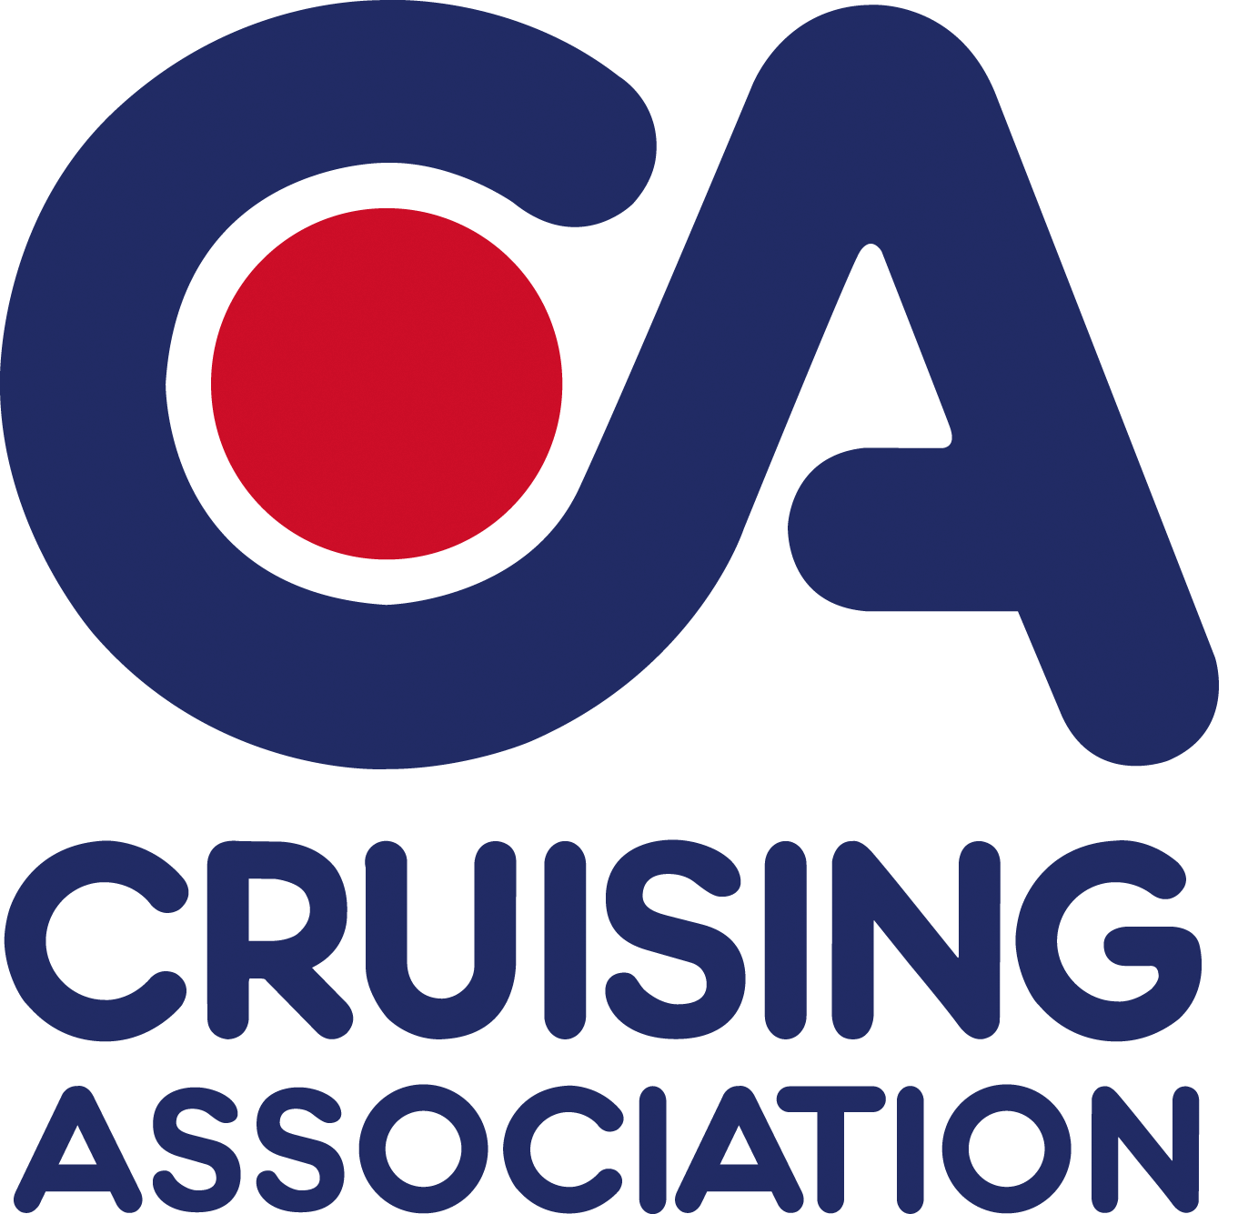

www.cruising.org.uk

Please reply to
Section Secretaries:

David Kench
1 Roland Villas, Hedsor Road
Bourne End, Bucks
SL8 5EJ

Tel: +44 (0)7974 575678
E-mail: thames_valley@cruising.org.uk

Riverside BBQ – Friday 16th May

Booking Form To Be Returned by 12th May

Venue: Upper Thames Sailing Club

Bar Open: 6.30pm. BBQ Served From: 7.15pm

Cost: £10 per head.

Please make cheques payable to CA Thames Valley

First name:
Last Name:
Email address:
Number in party:
Amount payable:

Menu
BBQ Chicken, Cumberland Sausage, Burger in Bun
Choice of Three Salads
Drinks not included in cover price

