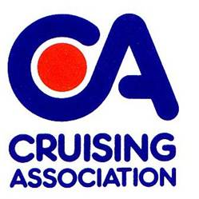
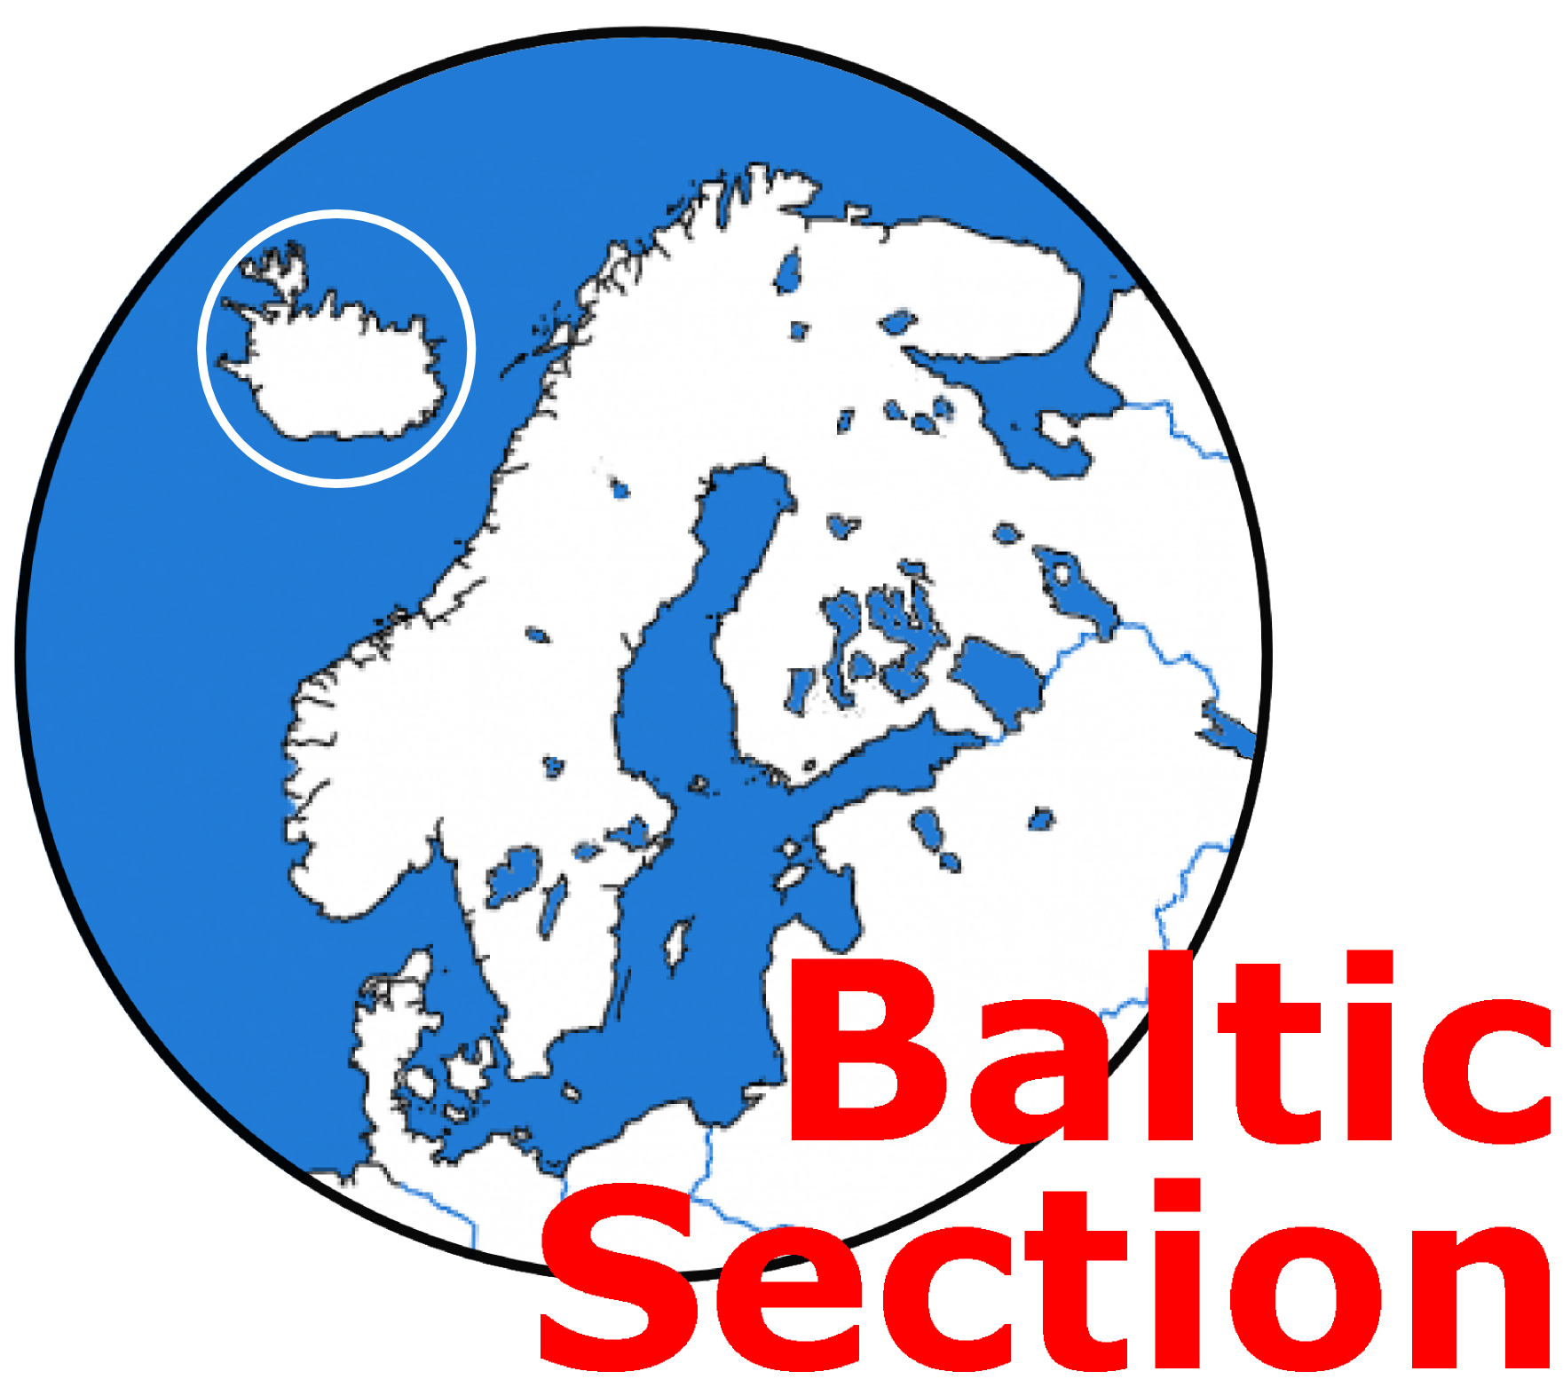
SWEDEN
INFORMATION DAY

Saturday 18th November 2023

1100 to approx. 1600

At CA House, 1 Northey Street, Limehouse Basin, London E14 8BT

One of the most popular countries bordering the Baltic, Sweden has a great variety of sailing areas, including beautiful archipelagos, huge lakes and several canals. Come along to find out more about the country, the people and what you can expect when there.

Presenters: Keith Mann, Gerald Freshwater, Dick Beddoe, Fay Cattell.

EVERYONE WELCOME.

Admission: CA members £10 (Snack Lunch).
Non CA members £15 each for the meeting plus £10 for lunch i.e. £25.
[The £15 meeting fee will be refunded to anyone joining CA on the day or very shortly thereafter].

PLEASE NOTE – prior booking and payment necessary.

Numbers will be limited so early application essential.
Please complete the Booking Form below and return by email to: baltic@theca.org.uk or by post to: Fay Cattell at 31 Blackbrook Park Avenue, Fareham, Hants PO15 5JN Tel 01329 28460 and make payment as follows.
The preferred method of payment is by bank transfer (regret no credit cards). BACS details are:
Sort Code: 20-36-98. Account number: 20621196 Account name: Cruising Association Baltic Section
Please add surname + SWE as the payment reference.

If you wish to pay by cheque please send a cheque (payable to Cruising Association – Baltic Section) with this form to Fay Cattell at the above address.
__________________________________________________________________________

Sweden Information Day, Saturday 18th November 2023

Please book places for the following

……………………………………………………………………………………………....

………………………………………………………………………………………………

………………………………………………………………………………………………

………………………………………………………………………………………………

Email address and telephone number of person making the booking:

…………………………………………………………………………………………………

